Assignment: Design Thinking

Prepared by: Balakrishnan Kirushan (ninja5)

### Problem Statement:

Design an intersection where two perpendicular roads meet. Both roads have one lane of traffic traveling in opposite directions. The intersection must meet minimum federal and state safety standards for vehicular and pedestrian traffic.

How could design thinking help you? Can you actually design a traffic intersection, define its rules and create a top view diagram of the same. Also, can you list down the use cases it will solve for and rooms or areas of improvement for later iterations. (like time dimension, e.g. one way between 7AM to 9AM)

Contents

Problem Statement: 1

Design Considerations and Objectives 3

Principles of Intersection Design 3

Pedestrian Movements. 4

Intersection Area 5

Functional and physical areas 5

Intersection Sight Distance 7

General Considerations 7

Channelization 9

Bicycle Facilities 10

Bicycle Lane 10

Sidewalks 12

Sidewalk Location 12

Horizontal Clearance 12

Bus Stops 12

Lighting 13

Crosswalks 13

Signals 14

Future Scope 14

Intersection Design

## Design Considerations and Objectives

The main objectives of intersection design are to facilitate the safe and efficient movements

of motor vehicles, buses, trucks, bicycles, and pedestrians. Intersection design should be

fitted closely to the operating characteristics of its users.

### Principles of Intersection Design

A prime function of intersections is to provide for changes in travel direction. Intersection

design goals may include the following:

* Consider all modes: bicycles, pedestrians, transit, and motor vehicles.
* Reduce the number of conflict points.
* Control relative speed.
* Coordinate design and traffic controls.
* Minimize skew angle.
* Avoid multiple and compound merging and diverging maneuvers.
* Separate conflict points.
* Favor the predominant flow.
* Segregate nonhomogeneous flows.
* Be consistent with local/neighborhood objectives.

High-capacity urban road intersections are expected to accommodate high vehicular traffic volumes at relatively high speeds. When two roads intersect, a large number of vehicles are likely to need the same intersecting area. Also sharing the space for pedestrians and bicyclists is highly important. The high demands often cause operational bottlenecks or points of congestion so the intersection must be designed and constructed for high capacity volumes in order to eliminate the bottlenecks.

High-capacity urban road intersections should be designed with the concept that geometric features should be used to:

* maximize efficiency for all modes,
* accommodate turning vehicles, and
* balance the requirements of all modes so they interact in a safe and efficient manner.

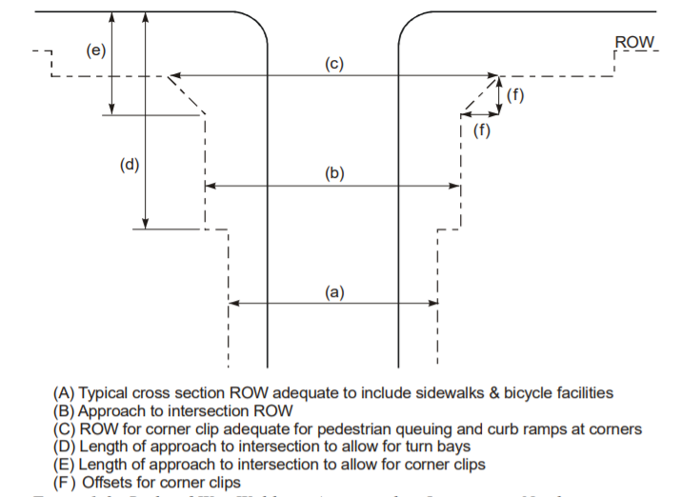

(a) Typical cross section ROW(Right-of-way) adequate to include sidewalks & bicycle facilities

(b) Approach to intersection ROW

(c) ROW for corner clip adequate for pedestrian queuing and curb ramps at corners

(d) Length of approach to intersection to allow for turn bays

(e) Length of approach to intersection to allow for corner clips

(f) Offsets for corner clips

Two multilane arterials operating at or near capacity volumes will create a bottleneck at their intersection unless the cross sections of the arterials become wider at and on the approaches to the intersection. In order to provide for the widened cross section, ROW widths must be increased at and on the approaches to the intersection. Figure illustrates how the ROW could be widened to accommodate the addition of turn lanes, pedestrian facilities, and transit needs at an intersection.

### 

### Pedestrian Movements.

The safety and efficiency of pedestrian movements at an intersection may be improved by providing:

* Good sight distances
* Marked crosswalks
* Accessible pedestrian signals
* Push button actuations with locator tones
* Short, direct crossings
* Adequate time for crossing at the signal
* Protected crossing phase at the signal
* Low speeds

## Intersection Area

### Functional and physical areas

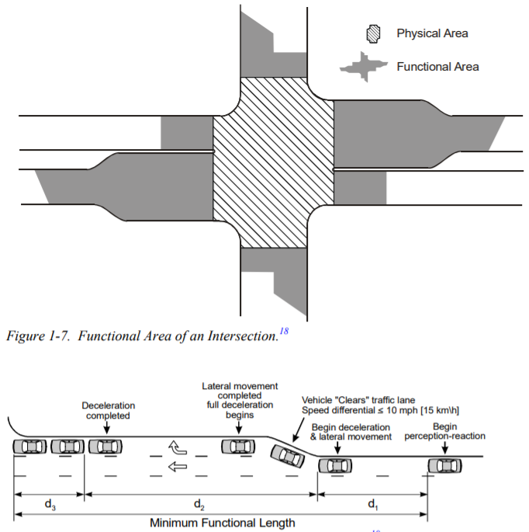

The functional area of an intersection covers both the upwards and downwards area of the physical area shown in the above figure. The functional area should be consists of following

1. Perception - reaction area (d1): The distance traveled during the perception-reaction area will depend upon vehicle speed, driver alertness, and driver familiarity with the location.
2. Maneuver distance (d2): When moving towards the left- or right-turn lane, the maneuver distance includes the length needed for both braking and lane changing.
3. Queue-storage distance (d3): The storage length should be sufficient to accommodate the queues expected during a typical peak period.

## Intersection Sight Distance

### General Considerations

The operator of a vehicle approaching an intersection should have an unobstructed view of

the entire intersection and an adequate view of the intersecting highway to permit control of

the vehicle to avoid a collision. When designing an intersection, the following factors should

be considered

* Adequate sight distance should be provided along both highway approaches to allow

drivers and other road users to anticipate and avoid potential collisions.

* Gradients of intersecting roadways should be as flat as practical on sections that are to

be used for storage of stopped vehicles.

* Combination of vertical and horizontal curvature should allow adequate sight distance

of the intersection.

* Traffic lanes should be clearly visible at all times.
* Lane and crosswalk markings and signs should be clearly visible and understandable

from a desired distance.

* Intersections should be evaluated for the effects of barriers, rails, retaining walls,

landscaping, curbside parking, and other vertical elements on sight distance.

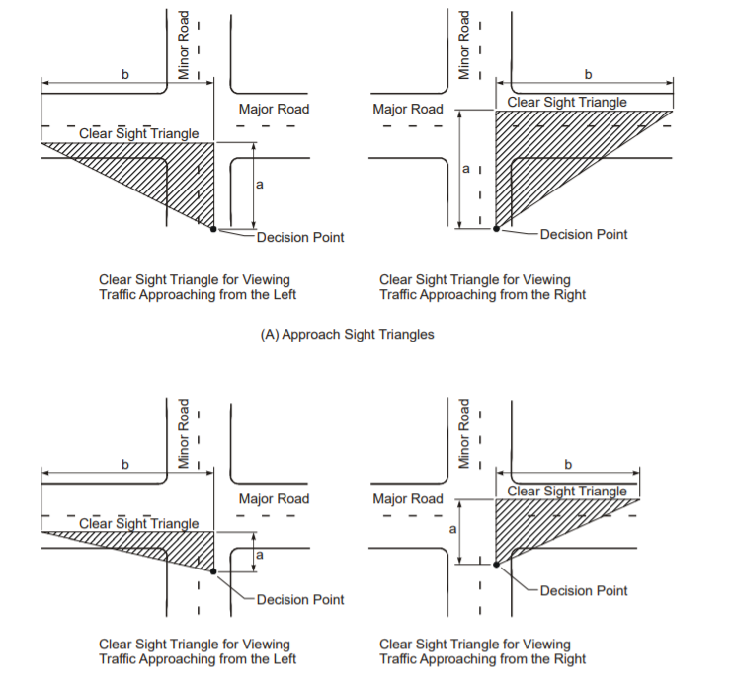

## Channelization

Channelization is used to control, direct, or divide vehicle paths. Where the use of large radius for turning movements results in areas of pavement too large for the proper control of traffic, channelization in the form of raised islands or pavement markings may be used to enhance the guidance of vehicles.

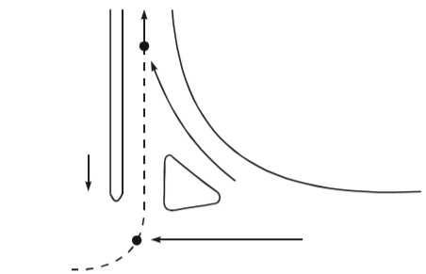

Also channelization will help to keep vehicles within well-defined paths that minimize the area of conflict.

## Bicycle Facilities

### Bicycle Lane

Bicycle lanes are located at the right side of the roadway, and they carry bicycle traffic in

the same direction as the adjacent motor vehicle traffic. On one-way roadways bicycle

lanes are still generally located on the right side of the roadway to avoid violating driver

Expectancy.

Bicycle lane markings should not extend across intersections in most cases, although in some exceptionally complex intersections dotted guidelines may be used. Bicycle lane markings should never cross crosswalks. If no crosswalks are present the bicycle lane markings should stop at the near side street property line extension and resume at the far side street property line extension

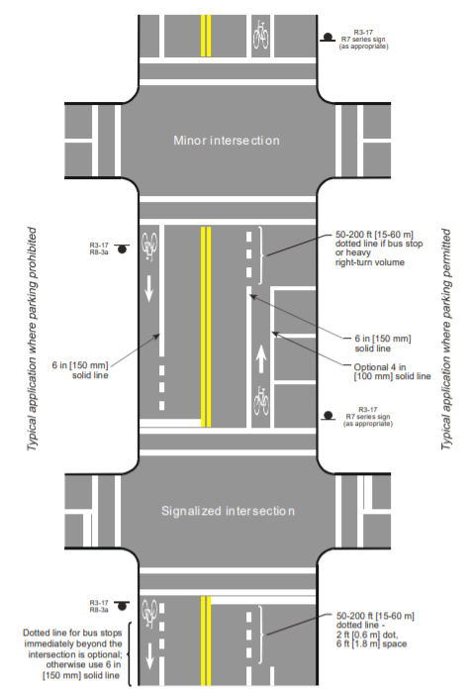

## 

## Sidewalks

Sidewalks provide distinct separation of pedestrians and vehicles, serving to increase pedestrian safety as well as to enhance vehicular capacity. A sidewalk is a paved area (typically concrete) that normally runs parallel to vehicular traffic and is separated from the road surface by a gutter. Properly planned, designed, and constructed sidewalks are essential for increasing pedestrian mobility, accessibility, and safety, especially for persons with disabilities, older pedestrians, and children.

### Sidewalk Location

It is desirable to provide a buffer space between the traveled way and the sidewalk for

pedestrian comfort, especially adjacent to high-speed traffic.

### Horizontal Clearance

A clear recovery area, or horizontal clearance, should be provided along roadways as practical. Ideally this area would be free of obstacles such as unyielding sign and luminaire supports, non-traversable drainage structures, utility poles, and steep slopes. Obstacles on the roadside can encroach into the pedestrian’s path of travel and be difficult for visually impaired pedestrians to detect with a cane. The typical cane techniques do not locate objects extending into the travel path above 15 to 27 inches [38 to 69 cm] before contact with the body

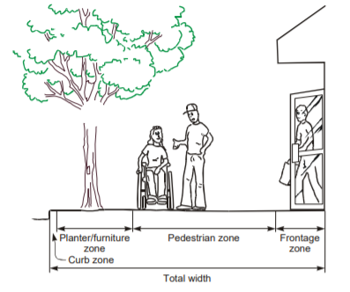

## Bus Stops

Placement of Bus Stop Bus stops can be located far-side, near-side, or at midblock in relation to an intersection. Some communities have a strong preference for the use of farside or nearside bus stops. I prefer a mid-block bus stop for the intersection because it can minimize intersection sight distance restrictions for vehicles and pedestrians.

## Lighting

Lighting may improve the safety of the intersections, as well as efficiency of traffic operations. Statistics indicate that nighttime crash rates are higher than crash rates during daylight hours because of lower visibility. In urban and suburban areas where there are concentrations of pedestrians and roadside and intersectional interferences, fixed-source lighting has been shown to reduce crashes.

## Crosswalks

A crosswalk is the portion of roadway designated for pedestrians to use in crossing the

Street.

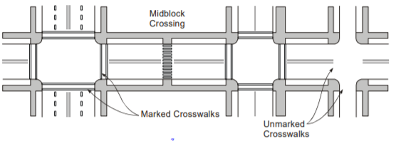

Pedestrians are most vulnerable to injury from motor vehicles at intersections. Therefore,

crosswalks should be designed to minimize exposure of pedestrians to motor vehicles. I prefer marked crossings to encourage pedestrians to cross at specific locations in an effort to minimize the number of pedestrian and vehicle conflict areas.

Considerations when marking crosswalks include the following:

* Crosswalk locations should be convenient for pedestrian access.
* Crosswalk markings alone are unlikely to benefit pedestrian safety.
* Marked crosswalks can assist persons with low vision.
* Curb ramps are to be within the crosswalk markings so that pedestrians do not have to leave the crosswalk to access the curb ramp.

## Signals

The primary function of traffic control signals is to assign the right of way at intersecting streets where without such control an excessive delay or hazard to vehicles and/or pedestrians would result.

The portion of the traffic signal that is most visible to the motorists and pedestrians is the signal head. The signal head will be mounted over the traffic lanes or adjacent to the roadway that contains the displays for controlling which traffic stream enters the intersection.

A minimum of two signal faces is required for the major movement on the approach, even if the major movement is a turning movement. The two signal faces should be visible continuously from a point at least the minimum sight distance.

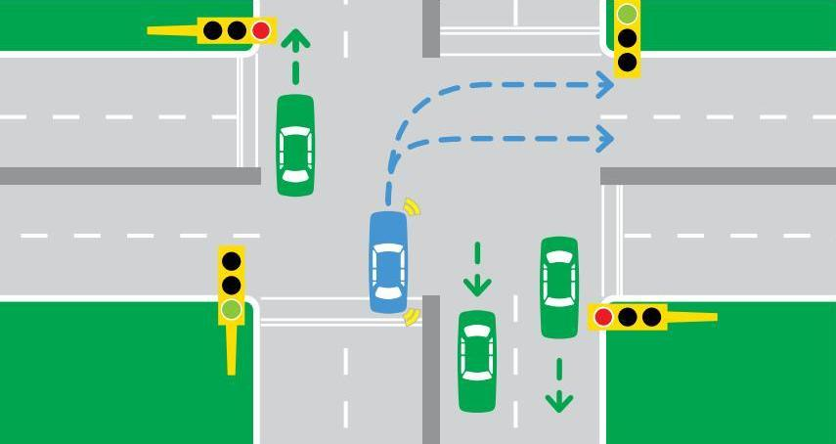

## 

## Future Scope

As technology and the population grow, the need for expanding existing and adding or expanding the intersection is must. So when design stages itself we should provide some buffer in terms of area as well as room for future enhancement including in the design leads to better and reliable solution.

1. Giving more area on sidewalks and giving more areas or buffer areas when building channelization will be helpful in the future enhancement of roads as well as controlling the traffic in the intersection.
2. Planned road separation in the middle of the road and buffer areas in the sidewalks are essential when planning to construct an overhead bridge due to traffic constraints. The more area will be utilized to build the foundation of the overhead bridge and give the room for more roads to construct in the intersection.
3. Any utilities upgradation within an intersection such as gas lines, electricity lines or telecommunication fiber-optic cables may have an impact on the design of that intersection. Utilities will require manholes,poles, and other stations. Keeping adequate buffers in need of future enhancement of utilities will fulfill its need.